5th International Symposium
on Natural Resources Management

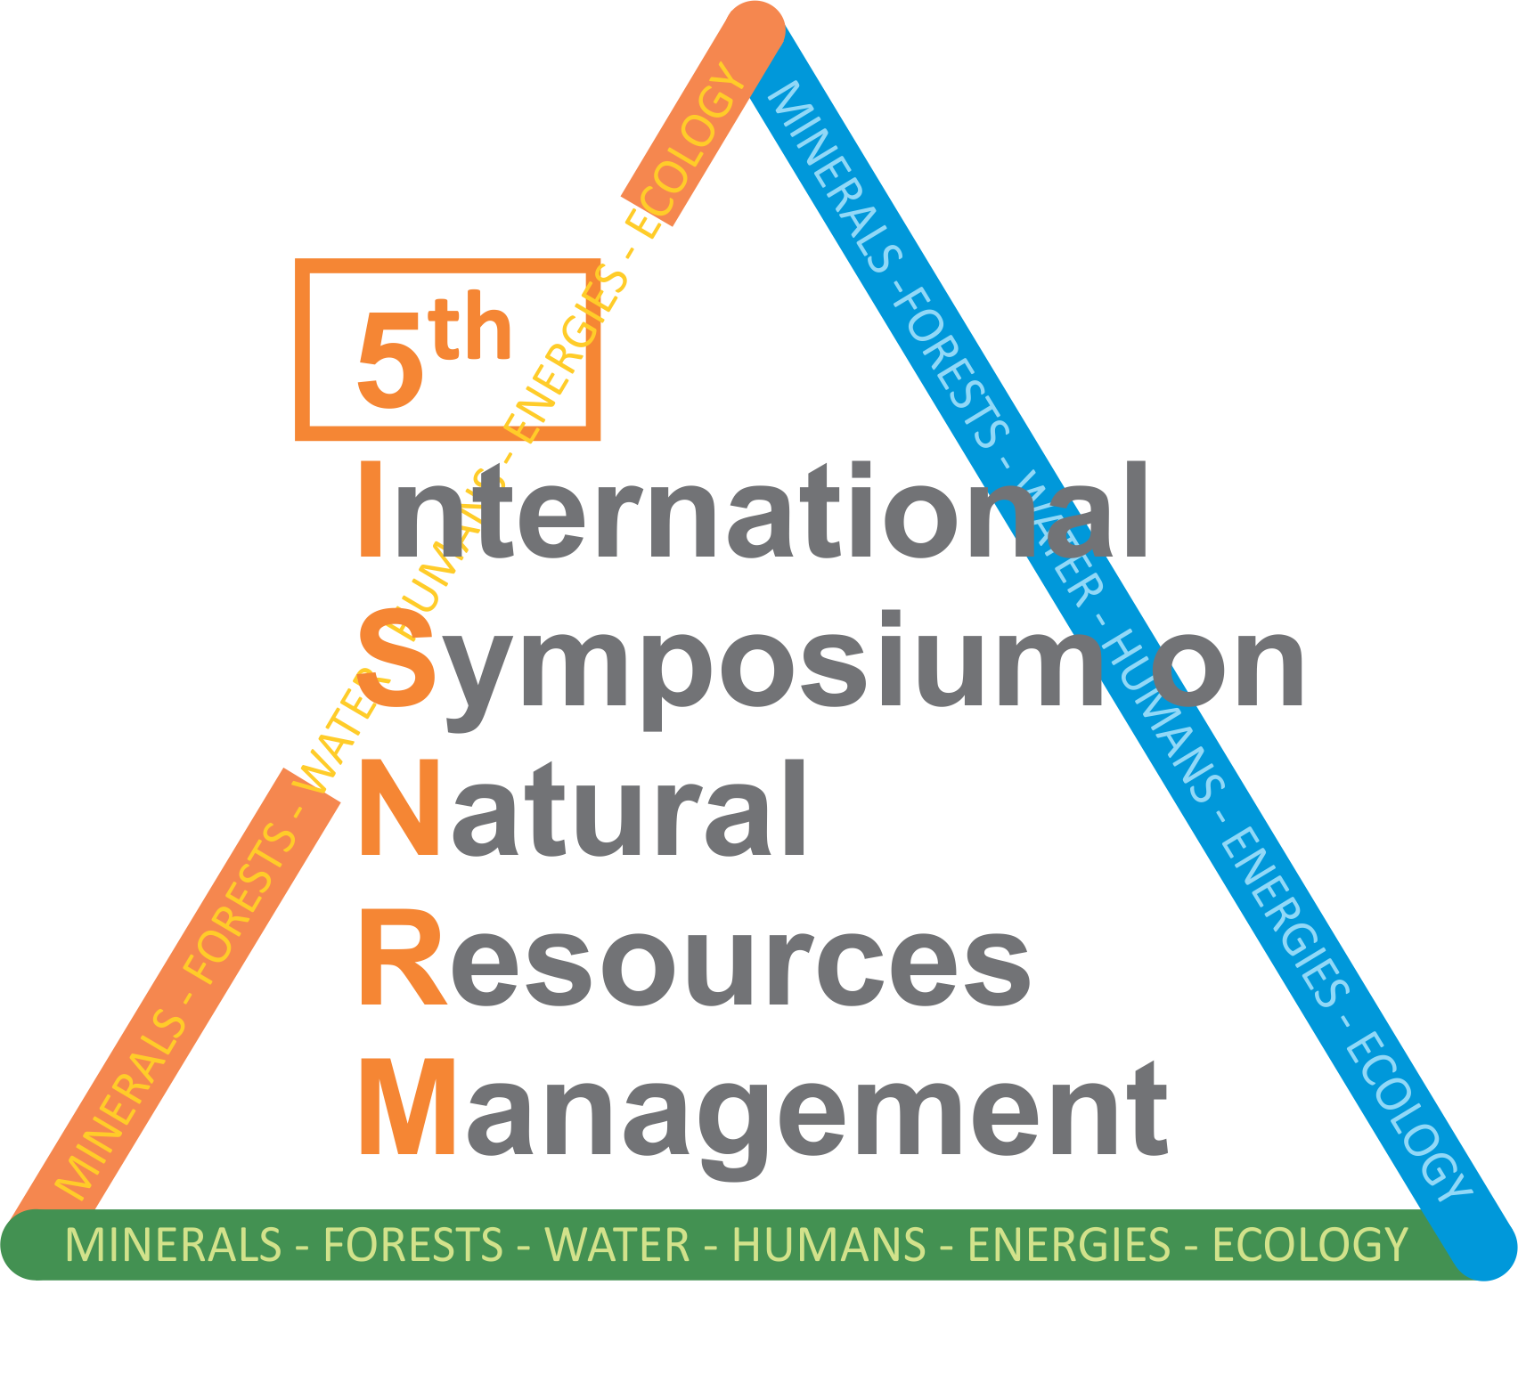 | May 23rd , 2015.  FACULTY OF MANAGEMENT ZAJEČAR  REPUBLIC OF SERBIA  www.fmz.edu.rs  simpozijum@fmz.edu.rs

REGISTRATION FORM

TITLE OF THE PAPER

Autor’s Name∗
Affiliation
Address

Autor’s Name
Affiliation
Address

Autor’s Name
Affiliation
Address

ABSTRACT: (not more than 100 words)

KEY WORDS: (not more than 6 words)

REZIME: (ne više od 100 reči)

KLJUČNE REČI: (ne više od 6 reči)

 e-mail address of the correspondent author

